**Code:**

**Navigation:**

<!DOCTYPE html>

<html lang="en">

<head>

<meta charset="UTF-8">

<meta name="viewport" content="width=device-width, initial-scale=1.0">

<meta http-equiv="X-UA-Compatible" content="ie=edge">

<title>Document</title>

<style>

body {

border:1px solid black;

}

header {

background-color: darkgrey;

text-align: center;

font-size: 20px;

}

nav{

float:left;

}

article{

background-color:lightpink;

margin-left:10%;

width:80%;

height:80%;

float:left

}

footer {

clear: both;

background-color: darkgrey;

text-align: center;

font-size: 20px;

}

</style>

</head>

<body>

<header>

<h2><i>Personal Information</i></h2>

</header>

<section>

<nav>

<ul>

<li><a href="Index.html" target="iframe_load">Personal Highlights</a></li>

<li><a href="Projects.html" target="iframe_load">Project</a></li>

<li><a href="Experience.html" target="iframe_load">Experience</a></li>

<li><a href="Personal Biography.html" target="iframe_load">Personal Biography</a></li>

<li><a href="ContactMe.html" target="iframe_load">Contact me</a></li>

</ul>

</nav>

<article>

<iframe height="340px" width="100%" src="Index.html" name="iframe_load"></iframe>

</article>

</section>

<footer>

<p>CopyRights 2018..</p>

</footer>

</body>

</html>

**Profile highlights:**

<!DOCTYPE html>

<html lang="en">

<head>

<meta charset="UTF-8">

<meta name="viewport" content="width=device-width, initial-scale=<1.0>">

<meta http-equiv="X-UA-Compatible" content="ie=edge">

<title>Document</title>

</head>

<body>

<header>

<h1>Profile Highlights</h1>

</header>

<main>

<section style="float:left">

<table>

<tr>

<td>

<label>

<strong>Name:</strong>

</label>

</td>

<td>

<label>RamaSubasree.M.S</label>

</td>

</tr>

<tr>

<td>

<label>

<strong>Company:</strong>

</label>

</td>

<td>

<label>

Cognizant Technology Solutions.

</label>

</td>

</tr>

<tr>

<td>

<label>

<strong>Designation:</strong>

</label>

</td>

<td>

<label>

Software Developer

</label>

</td>

</tr>

<tr>

<td>

<label>

<strong>Experience:</strong>

</label>

</td>

<td>

<label>

2.6 years

</label>

</td>

</tr>

<tr>

<td>

<label>

<strong>Technology:</strong>

</label>

</td>

<td>

<label>

Dot Net

</label>

</td>

</tr>

</table>

</section>

<aside style="float:left">

<img src="Suba.jpg" style="float:left;width:250px;height:250px;"/>

</aside>

</main>

</body>

</html>

**Projects:**

<!DOCTYPE html>

<html lang="en">

<head>

<meta charset="UTF-8">

<meta name="viewport" content="width=device-width, initial-scale=1.0">

<meta http-equiv="X-UA-Compatible" content="ie=edge">

<title>Document</title>

</head>

<body>

<header>

<h1>Projects</h1>

</header>

<main>

<table>

<tr>

<td>

<strong>

Company:

</strong>

</td>

<td>

<label>

Cognizant Technology Solution

</label>

</td>

</tr>

<tr>

<td>

<strong>

Project

</strong>

</td>

<td>

<label>

XXX

</label>

</td>

</tr>

<tr>

<td>

<strong>

years

</strong>

</td>

<td>

<label>

2 years

</label>

</td>

</tr>

<tr>

<td>

<strong>

Technology

</strong>

</td>

<td>

<label>

Dot Net

</label>

</td>

</tr>

</table>

</main>

</body>

</html>

**Experience:**

<!DOCTYPE html>

<html lang="en">

<head>

<meta charset="UTF-8">

<meta name="viewport" content="width=device-width, initial-scale=1.0">

<meta http-equiv="X-UA-Compatible" content="ie=edge">

<title>Document</title>

</head>

<body>

<header>

<h1>Experience Details</h1>

</header>

<main>

<table>

<tr>

<td>

<strong>Company:</strong>

</td>

<td>

<label>Congnizant Technology Solution</label>

</td>

</tr>

<tr>

<td>

<strong>No. Of Years:</strong>

</td>

<td>

<label>2.8years</label>

</td>

</tr>

<tr>

<td>

<label>

<strong>Description:</strong>

</label>

</td>

<td>

<label>

I joined as fresher in cognizant.

</label>

</td>

</tr>

</table>

</main>

</body>

</html>

**Personal Bio:**

<!DOCTYPE html>

<html lang="en">

<head>

<meta charset="UTF-8">

<meta name="viewport" content="width=device-width, initial-scale=1.0">

<meta http-equiv="X-UA-Compatible" content="ie=edge">

<title>Document</title>

</head>

<body>

<header>

<h1>Personal Biography</h1>

</header>

<main>

<table>

<tr>

<td>

<strong>Name:</strong>

</td>

<td>

<label>RamaSubasree.M.S</label>

</td>

</tr>

<tr>

<td>

<strong>DOB:</strong>

</td>

<td>

<label>11-04-1994</label>

</td>

</tr>

<tr>

<td>

<strong>Degree:</strong>

</td>

<td>

<label>B.E</label>

</td>

</tr>

<tr>

<td>

<strong>Native:</strong>

</td>

<td>

<label>Tuticorin</label>

</td>

</tr>

<tr>

<td>

<strong>Work Location:</strong>

</td>

<td>

<label>Banglore</label>

</td>

</tr>

</table>

</main>

</body>

</html>

**Contact Me:**

<!DOCTYPE html>

<html lang="en">

<head>

<title>Contact US </title>

</head>

<body>

<header>

<h2>Contact Me</h2>

</header>

<form type="post" >

<table width="450px">

<tr>

 <td valign="top" >

   First Name: *

 </td>

 <td valign="top" align="right" >

<input type="text" id="fname" name="firstname" required placeholder="Enter First name">

 </td>

</tr>

<tr>

 <td valign="top"">

   Last Name: *

 </td>

 <td valign="top" align="right">

<input type="text" id="lname" name="lastname" required placeholder="Enter Last name">

 </td>

</tr>

<tr>

 <td valign="top">

   Email Address: *

 </td>

 <td valign="top" align="right">

  <input type="email" name="email" required placeholder="Enter Email">

 </td>

</tr>

<tr>

 <td valign="top">

   Contact Number: *

 </td>

 <td valign="top" align="right">

<input type="number" name="quantity" required maxlength="10" placeholder="Enter Contact">

 </td>

</tr>

<tr>

 <td valign="top">

   Comments:

 </td>

 <td valign="top" align="right">

<textarea id="remarks" name="remarks" placeholder="Write something.." required style="height:100px" > </textarea>

 </td>

</tr>

<tr>

 <td colspan="2" style="text-align:center">

  <input type="submit" value="Submit">

 </td>

</tr>

</table>

</form>

<footer>

<p> </p>

</footer>

</body>

</html>

**OutPut:**

**Profile highlights:**

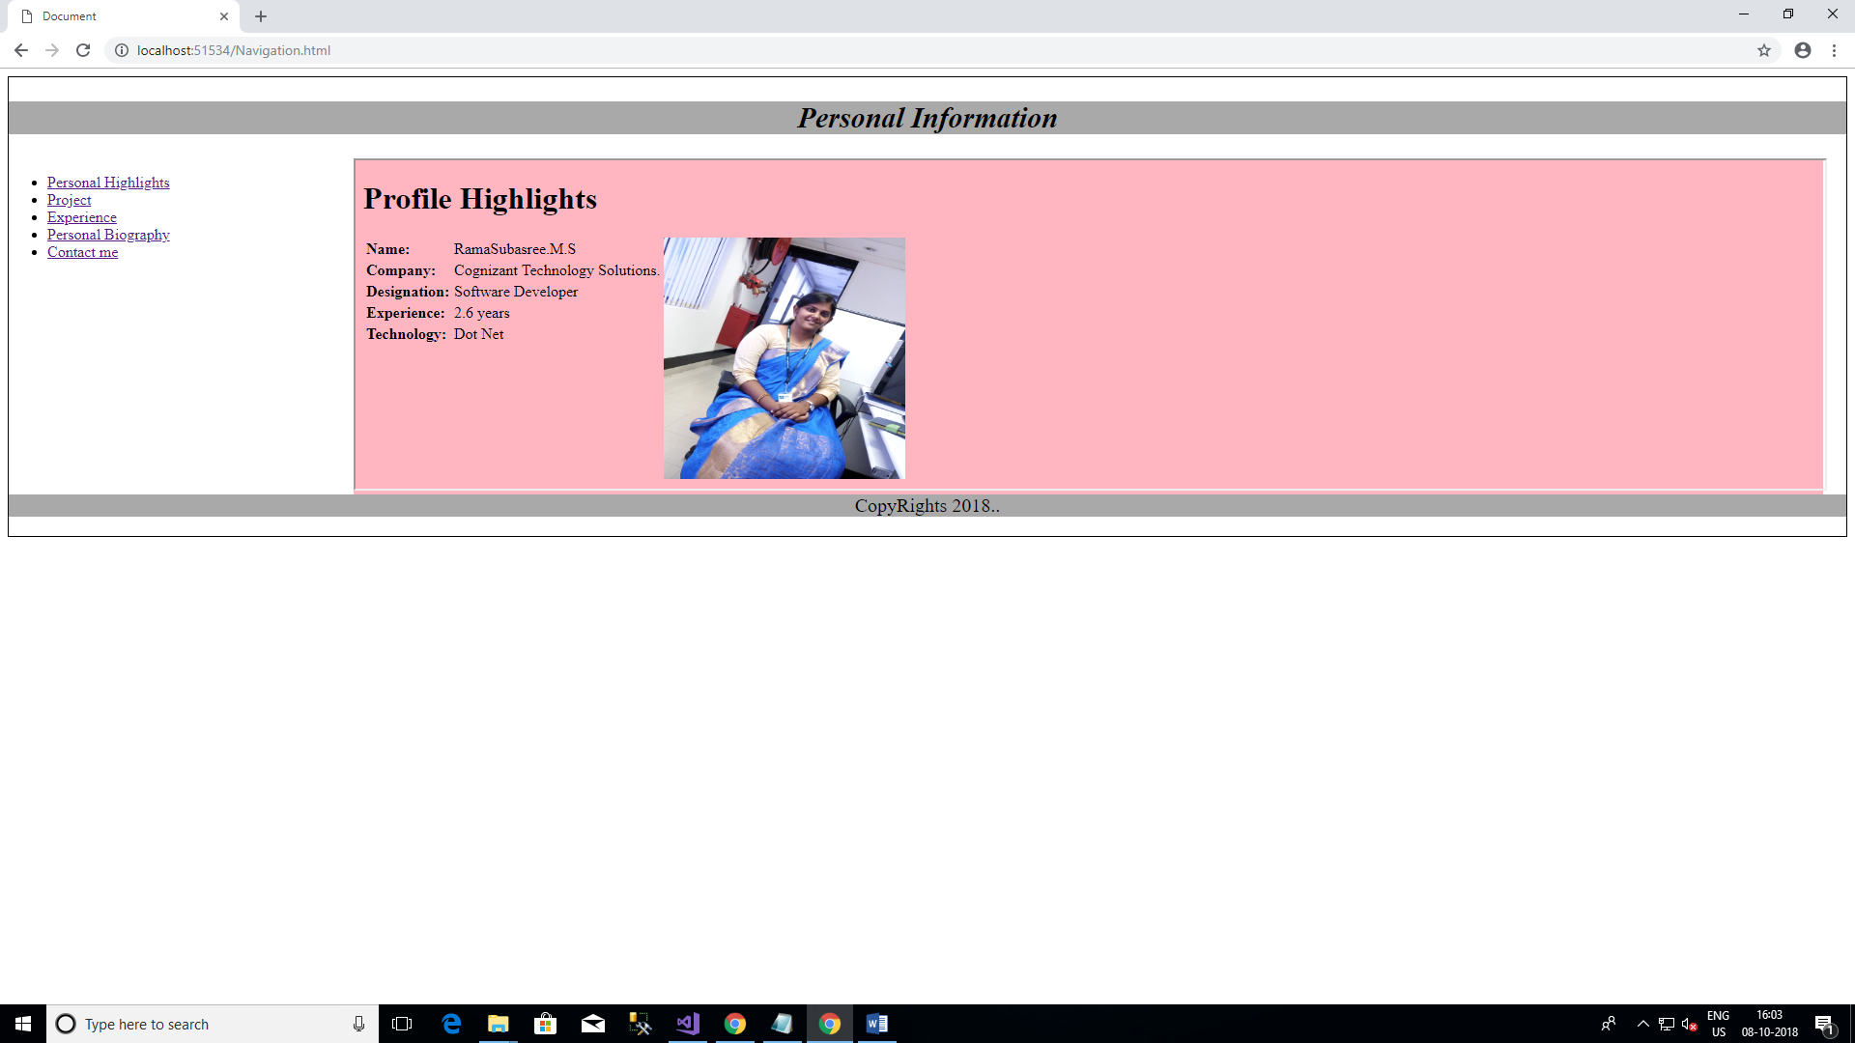

**Projects:**

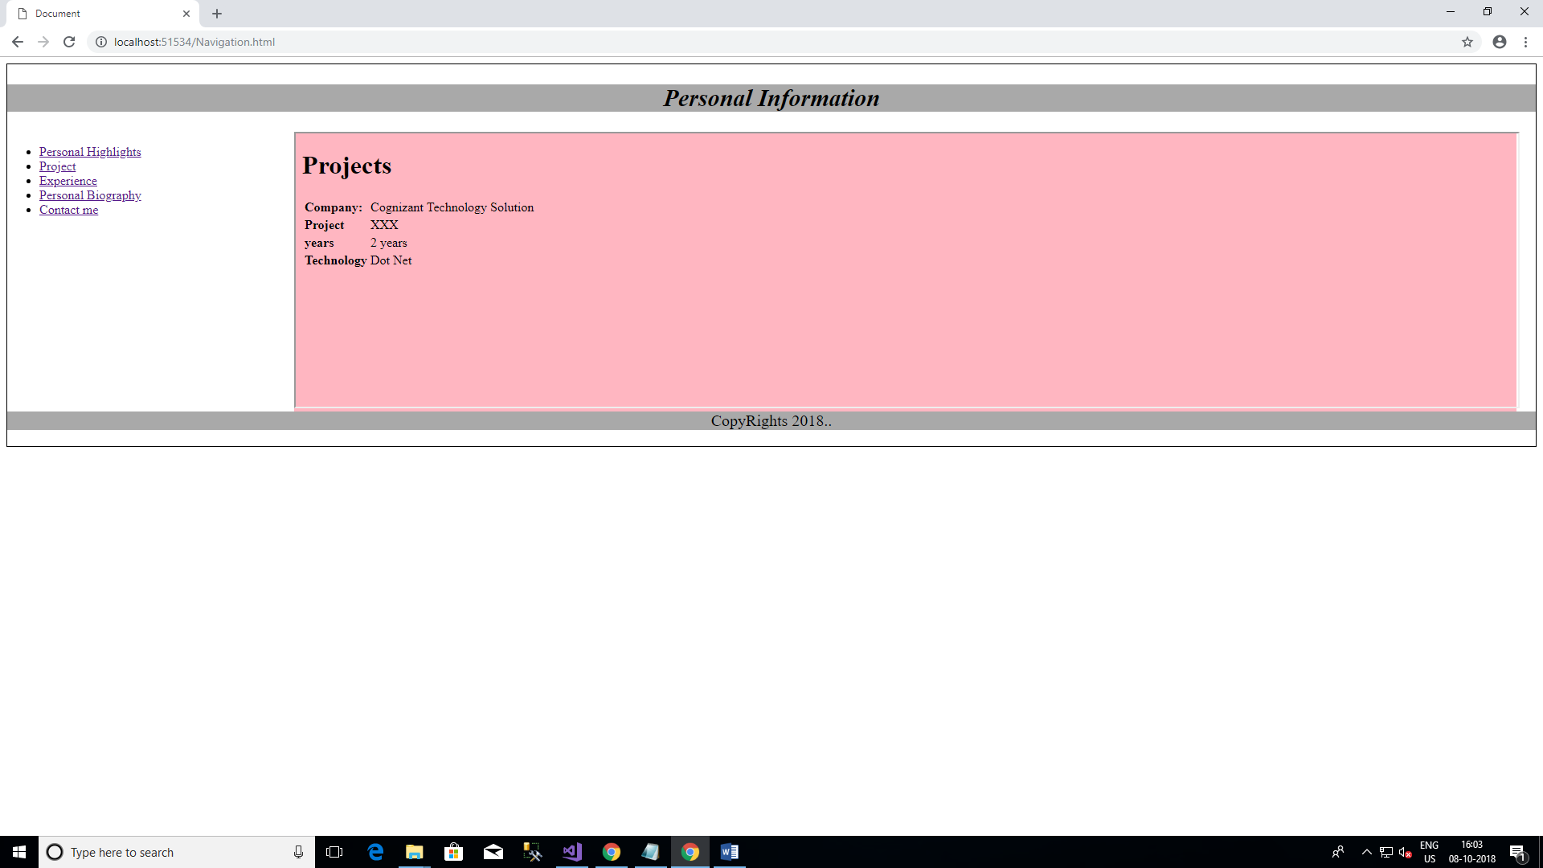

**Experience:**

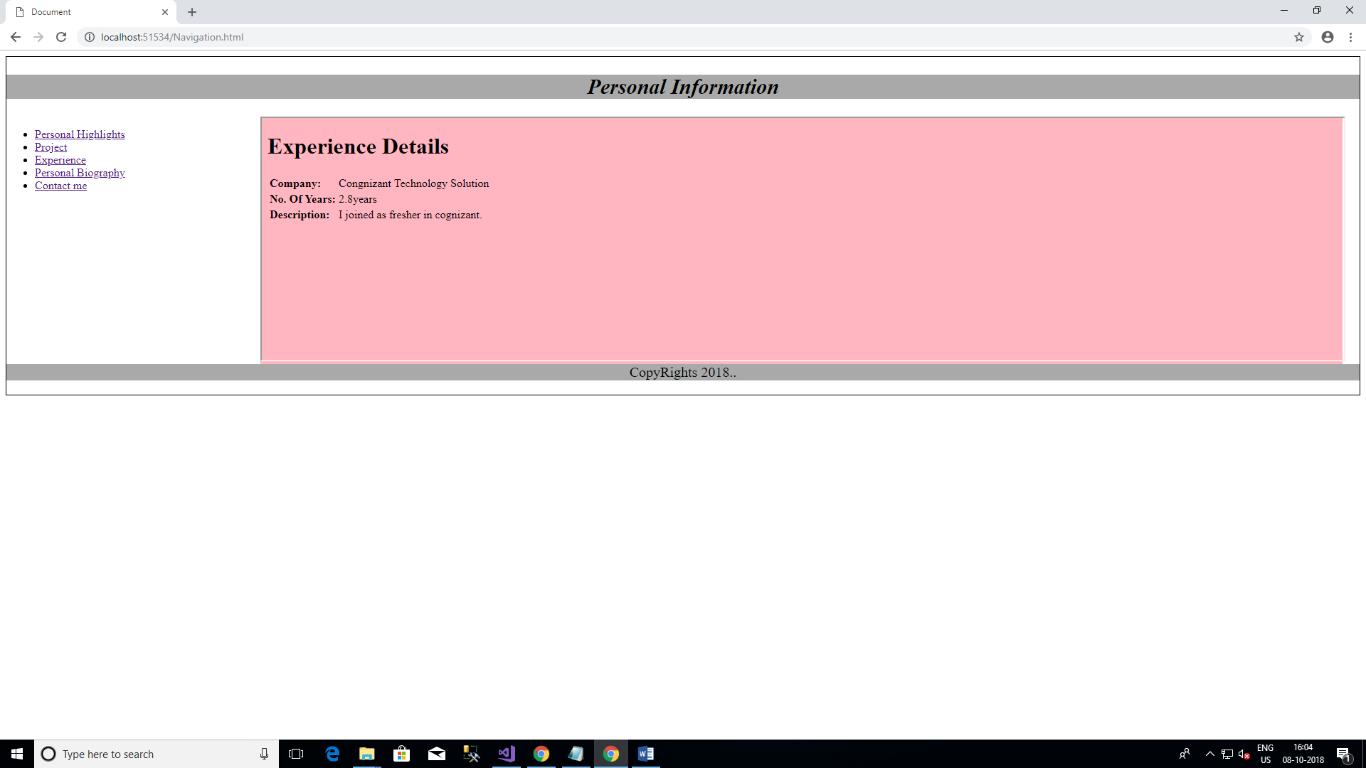

**Personal Bio:**

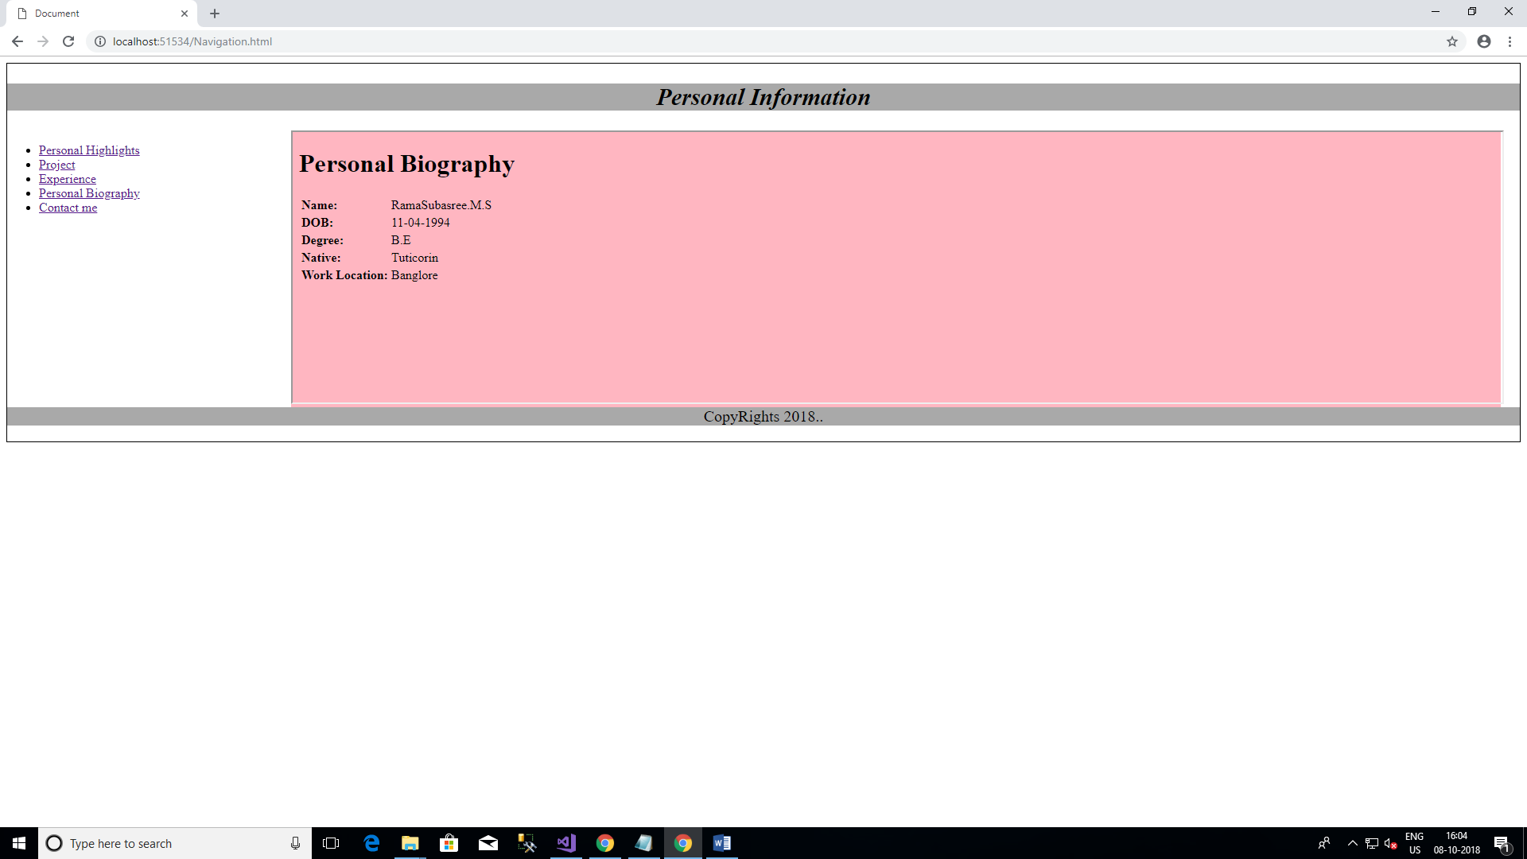

**Contact Me:**

